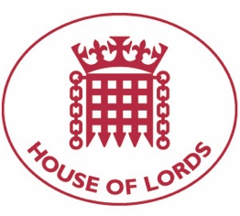
Hansard: Written Question on Azerbaijan: Gender Based Violence
26 May 2021

Baroness Cox: To ask Her Majesty's Government what representations they have made to the government of Azerbaijan about (1) fulfilling its obligations under international law to prevent, investigate and punish violence against women, (2) providing adequate protection and effective legal measures and redress for survivors, and (3) ratifying the Council of Europe Convention on preventing and combating violence against women and domestic violence.

Answered 10 June 2021

Lord Ahmad of Wimbledon: During her recent visit to Azerbaijan the Minister for the European Neighbourhood met with representatives of Civil Society, including survivors of domestic violence. During her meeting with President Aliyev she urged ratification of the Istanbul Convention alongside implementation of the National Action Plan on Women, Peace and Security. The UK Government will continue to urge Azerbaijan to sign and ratify the appropriate conventions to provide safeguards for women.

Hansard: Written Question on Azerbaijan: Gender Based Violence
26 May 2021

Baroness Cox: To ask Her Majesty's Government what assessment they have made of the report by Amnesty International Azerbaijan: Gender-Based Reprisals Against Women Must Stop, published on 12 May.

Answered 10 June 2021

Lord Ahmad of Wimbledon: The UK Government has made no assessment of this report. However, during her recent visit to Azerbaijan the Minister for the European Neighbourhood met with representatives of Civil Society, including survivors of domestic violence, and during her meeting with President Aliyev she urged signature of the Istanbul Convention. We continue to urge the Government of Azerbaijan to sign the convention and encourage thorough investigations into allegations of violence against women.

