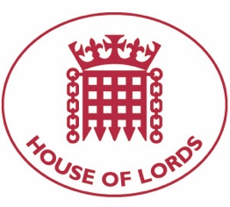
Hansard: Written Question on Nagorno Karabakh: Cultural Heritage
11 May 2021

Baroness Cox: Her Majesty's Government what action they are taking to support UNESCO's proposal of a mission to take stock of the situation regarding cultural properties in and around Nagorno-Karabakh.

Answered 17 May 2021

Baroness Barran: As signatories to the Hague Convention of 1954 for the Protection of Cultural Property in the Event of Armed Conflict, the UK supports the work of UNESCO in working with the relevant authorities in Armenia and Azerbaijan to protect cultural properties at risk in Nagorno-Karabakh. We support the work of the Minsk Group and hope UNESCO- appointed inspectors will be given unfettered access to ensure the effective safeguarding of the region’s heritage. The Minister for European Neighbourhood and the Americas at the Foreign, Commonwealth and Development Office has emphasised the importance of protecting all cultural heritage sites to both the Armenian and Azerbaijani Governments.

