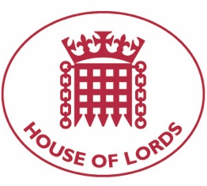
Hansard: Written Question on Religious Freedom
14 September 2021

Baroness Cox: To ask Her Majesty's Government what assessment have they made of whether extremist Islamist ideology is a driver of intercommunal attacks in Nigeria; and what assessment they have made of the findings of the Bishop of Truro’s Independent review of persecution of Christians and freedom of religion or belief.

Answered 29 September 2021

Lord Ahmad of Wimbledon: The Government condemns all incidents of intercommunal violence in Nigeria, the devastating effects of which are felt by communities of different faiths. The underlying drivers of intercommunal violence are complex and frequently relate to competition over resources and increasing criminality. Islamic extremism is a driver of conflict in the North east and not a driver of intercommunal violence.
We have accepted the recommendations of the Bishop of Truro's report. On Nigeria, the report considered intercommunal violence in the Middle Belt and terrorism in the North East. In response to the issues raised in the report on intercommunal violence, the Government co-hosted a Wilton Park conference on 'Fostering Social Cohesion in Nigeria' in February 2020, exploring the complex causes of conflict and solutions to help ease tensions and reduce violence. Since then, we have increased our visits to areas affected by violence to engage with state governments, civil society, faith and community leaders and affected communities. The Minister for Africa visited Nigeria in April, where he discussed insecurity across the country with the President's Chief of Staff, the Foreign Minister and community leaders.

