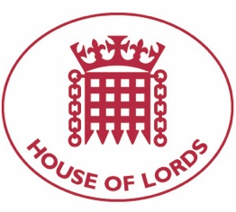

Hansard: Written question on Nigeria’s Humanitarian Situation
02 December 2021

Baroness Cox: T To ask Her Majesty's Government what were the findings of the British High Commission's recent visit to Benue State in Nigeria; and what steps they are taking in response.

Answered 02 December 2021

Minister for Pacific and the Environment, Lord Goldsmith of Richmond Park: We strongly condemn the actions of the Sudanese military on 25 October to detain Prime Minister Hamdok and members of the civilian government, declare a state of emergency and unilaterally dissolve the transitional government. The actions of the military represents a betrayal of the Sudanese people and their journey to democracy. The UK will consider the full range of policy tools at our disposal to protect human rights and deter violations, including sanctions. It is longstanding practice not to speculate on future sanctions designations as to do so could reduce the impact of any action. We urge Sudan's military leadership to reverse their course, to release detained politicians, and to ensure Sudanese people can protest without fear of violence.

Hansard: Written Question on Nigeria’s Humanitarian Situation

Baroness Cox: To ask Her Majesty's Government what assessment they have made of the US State Department's decision to remove Nigeria from its list of Violators of Religious Freedom.

Answered 02 December 2021

Minister for Pacific and the Environment, Lord Goldsmith of Richmond Park: The removal of Nigeria from the list of Violators of Religious Freedom is a matter for the Government of the United States of America.

