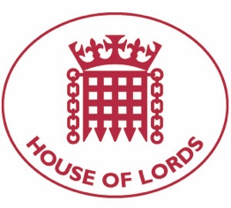

Hansard: Written Question on Sudan: Military Coups
26 October 2021

Baroness Cox: To ask Her Majesty's Government what plans they have to impose Magnitsky sanctions on the military officials responsible for the overthrow of the civilian government in Sudan.

Answered 04 November 2021

Minister for Pacific and the Environment, Lord Goldsmith of Richmond Park: We strongly condemn the actions of the Sudanese military on 25 October to detain Prime Minister Hamdok and members of the civilian government, declare a state of emergency and unilaterally dissolve the transitional government. The actions of the military represents a betrayal of the Sudanese people and their journey to democracy. The UK will consider the full range of policy tools at our disposal to protect human rights and deter violations, including sanctions. It is longstanding practice not to speculate on future sanctions designations as to do so could reduce the impact of any action. We urge Sudan's military leadership to reverse their course, to release detained politicians, and to ensure Sudanese people can protest without fear of violence.

Hansard: Written Question on Sudan: Military Coups
26 October 2021

Baroness Cox: To ask Her Majesty's Government what plans they have if any, to call a special session of the UN Human Rights Council regarding the situation in Sudan.

Answered 04 November 2021

Minister for Pacific and the Environment, Lord Goldsmith of Richmond Park: Together with partners, we are seeking a special session of the UN Human Rights Council as soon as possible in order to discuss the situation. The UK strongly condemns the military coup d'état and arrests of civilian members of Sudan's transitional government on 25 October. We have called on the security forces to immediately release those they have unlawfully detained. The Minister for Africa condemned this act in the strongest terms in the House of Commons on 25 October. We have since made public statements, including as the Troika with US/Norway on 26 October, calling for the restoration of transitional institutions, release of detainees and protection of civilians. Over the past two years, the UK has taken a leading role to support Sudan on their delicate path from oppressive autocratic rule to freedom and democracy. The actions of the military represents a betrayal of the Sudanese people and their journey to democracy.

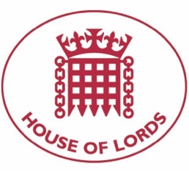

Hansard: Written Question on Sudan: Military Coups
26 October 2021

Baroness Cox: To ask Her Majesty's Government what steps they have taken to ensure the (1) protection, and (2) release of (a) Prime Minister Hamdok, and (b) Yasir Arman, following the overthrow of the civilian government in Sudan.

Answered: 04 November 2021

Minister for Pacific and the Environment, Lord Goldsmith of Richmond Park: We strongly condemn the actions of the Sudanese military on 25 October to detain Prime Minister Hamdok, Yasir Arman and members of the civilian government and unilaterally dissolve the transitional government. Together with the US and Norway we issued a Troika statement on 26 October condemning the actions taken by the military, calling for them to reverse course, to release detained politicians, and to ensure the Sudanese people can protest without fear of violence.
Prime Minister Hamdok has been released but is currently under house arrest. As a signal of support, our Ambassador and other senior members of the diplomatic community in Khartoum met with Prime Minister Hamdok on 27 October and were able ascertain that he is well, notwithstanding the circumstances, but still detained. The whereabouts and condition of other civilian members of the transitional government are still unknown.
Over the past two years, the UK has taken a leading role to support Sudan on their delicate path from oppressive autocratic rule to freedom and democracy. Having arrested the Prime Minister and others, the military have undermined the trust placed in them to deliver democracy, by the international community, and more importantly, by the people of Sudan. The acts of the military represents a betrayal of the Sudanese people and their journey to democracy.

