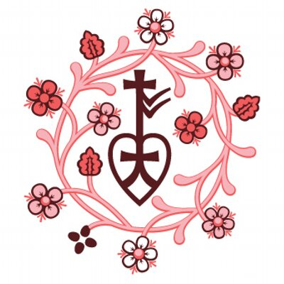
BURMA MARCH – MAY 2019 BRIEFING

JUNE-AUGUST BRIEFING 2018

Highlights

>Continued attacks on Christians and other religious minorities testify to the dangers of religious nationalism in Burma
> 100 years of Christianity is being celebrated in Kachin state. In the sub-township of the Kachin state, “Congregations from twelve local Baptist churches in Sadon area held special programs for the three-day celebration, attracting over 2000 visitors”
> Bangladesh tells the UN Security Council that they are unable to take more Burmese refugees. This comes near 18 months after more than 700,000 refugees, mainly Rohingya, fled to Bangladesh following military crackdown in Burma.

Humanitarian Figures

941,357 Estimated people in need of Humanitarian Assistance in Burma, according to UN November reports 106,900 Estimated Internally Displaced Persons (IDPs) in Kachin and northern Shan States, according to OCHA 128,200 Estimated Internally Displaced Persons in Rakhine IDP camps, according to latest UN figures 727,000 Estimated people displaced from Burma to Bangladesh since August 2018, the ISCG reports 128,000 Muslims, 95% of whom are stateless Rohingya, remain in camps more than six years after violence broke out in Rakhine State
286,000
People in disaster-prone Burma were temporarily displaced by monsoon seasonal floods in 2018

Key Developments

> The European Union has extended a ban on selling arms to Burma and prolonged sanctions against high-ranking officials over their role in the Rohingya crisis. "The sanctions include an embargo on arms and equipment that can be used for internal repression, an export ban on dual-use goods for use by the military and border guard police, and export restrictions on equipment for monitoring communications that might be used for internal repression," the EU said in a statement.
> Two Reuters journalist are freed after 500 days in prison after being arrested in December 2017. According to Reuters “Wa Lone, 33, and Kyaw Soe Oo, 29, had been convicted in September and sentenced to seven years in jail in a case that raised questions about Myanmar’s progress towards democracy and sparked an outcry from diplomats and human rights advocates. They were released under a presidential amnesty for 6,520 prisoners.”
> According to a new report by Amnesty International, Burma’s Rohingya Muslims and other minorities are facing fresh atrocities and human rights violations at the hands of the military. The new evidence shows that multiple communities have borne the brunt of the latest onslaught. Amnesty conducted 81 interviews, including 54 on the ground in Rakhine state with ethnic Rakhine, Mro, Rohingya and Khami villagers, belonging to the Buddhist, Christian and Muslim faiths.
their home country.

Context

Myanmar (Burma) is a highly ethnically diverse country, consisting of 7 states and headed by de facto leader State Counsellor Aung San Suu Kyi since free elections in 2015. Burma’s history of British colonisation has had a detrimental effect on internal ethnic divisions, and following independence in 1948 intercultural violence erupted between the national Government army (Tatmadaw) and ethnic opposition armies. In the subsequent years, ethnic tensions remained and from 1962 to 2011 Burma was under the rule of a highly repressive military junta.

Most of the population identifies at Buddhist (88%). Prevalent in the media is the Rohingya crisis, whereby roughly 900,000 Muslims have fled to Bangladesh since early 2017 following growing attacks by the Government of Myanmar military that claim they are dispelling terrorists, however there is mounting evidence to suggest that religion plays a significant role and has been deemed as “ethnic cleansing”. Less well documented is the persecution of Christians who make up 6.2% of the Burmese population that claim they are being attacked by the junta because of their faith.
There are numerous ethnic armies operating in Burma and regular clashes with the Tatmadaw has displaced thousands of civilians over the decades succeeding the end of British rule.

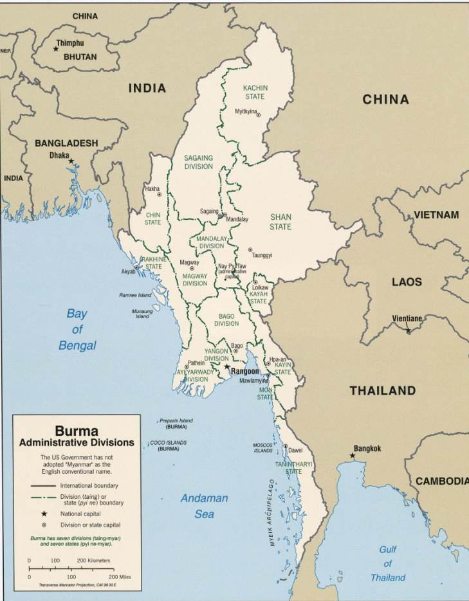
Ethnic Arms Operations (EAOs) Active in Burma
› Kachin Independence Army (KIA) was formed by soldiers that defected from the regime army in 1962 to fight for self-determination.
› Karen National Liberation Army (KNLA) signed a ceasefire with the Tatmadaw in 2015 however it was violated in 2018, leading to armed clashes.
› Arakan Liberation Army (ALA) has operated in Rakhine state since 2009.
› Arakan Rohingya Salvation Army (ARSA) are a newly formed group who claimed responsibility for the attacks in 2017 that catalysed the ongoing Rohingya crisis.
› Shan State Army-South (SSA-S) is one of the largest insurgent groups in Burma.
› Shan State Army-North (SSA-N) emerged following alliance with the Communist Party of Burma and an internal split in SSA in 1996.
› Ta’ang National Liberation Army (TNLA) operates in Tawngpeng, Shan State, aiming for self-determination for the Ta’ang people.
› The Northern Alliance is a military coalition between ALA, KIA, Kokang’s Myanmar National Democratic Alliance Army (MNDAA), and TNLA against the Tatmadaw.

Map of Burma Administrative Divisions
HART’s partner Shan Women’s Action Network (SWAN) is located in Shan State, and also provides assistance to displaced populations in Thailand.
Health and Hope, run by Dr SaSa is located in Chin State.
Doh Say works mainly in Karenni (Kayah) state.

Latest Developments
Environmental and Civil Society Groups Organizing Around Burma
Environmental rights and civil society organized around Burma demanding putting an end to large-dam projects. “The Burma Rivers Network, Save the Salween Network and civil society groups who want to stop the damming of Burma’s rivers and the destruction of the environment came together to celebrate the country’s vast free-flowing rivers and to declare that no large dams must be built on these vital waterways.”
“We are strongly opposed to the Union Government’s plans to build over 50 large hydropower dams on our rivers, mainly for the export of power to neighboring countries. These dams directly threaten and exploit the fragile ecology of the rivers and the ethnic communities who rely on them for their survival and for the survival of their cultural heritage.”
The groups pointed out that the current government’s support for the construction of large hydropower dams in areas of ongoing civil war is leading to an intensification of armed conflict, human rights violations, especially including women and children, and directly contradicts the principles of federal democracy.
Bangladesh Urges Steps be taken towards Refugee Repatriation
Bangladesh urges US to help Rohingya refugees. Bangladesh Disaster Management and Relief Minister Enamur Rahman on Sunday said he asked the U.S. to help find a way to repatriate the more than 1 million Rohingya refugees from Myanmar, stating “we want amicable repatriation with nationality rights and honor”. The US restated their commitment to helping those affected by the Rohingya crisis. The U.S. Embassy statement said the United States was contributing $45.5 million to the United Nations World Food Program to support the Rohingya refugees in Bangladesh. It comes on top of the $60 million the U.S. pledged at the launch of the 2019 U.N. Joint Response Plan in Geneva on Feb. 15.
Bangladesh asks Burma to alleviate the difficulties they enforce which makes Rohingya repatriation difficult. “Bangladesh particularly emphasized removing legal and administrative barriers to ensure basic rights of the returnees including freedom of movement, guaranteeing their safety and security, and positive steps towards a well-defined time-bound pathway to citizenship that would encourage the Myanmar residents to return voluntarily.”
Burmese Government Criticized for Crackdowns on Freedom of Expression
Human Rights Watch urges Myanmar government to repeal laws criminalizing freedom of expression. According to Human rights watch, Myanmar’s authorities have in recent weeks engaged in a series of arrests of peaceful critics of the army and government. They urged parliament to repeal or amend repressive laws used to silence critics and suppress freedom of expression when parliament is back in session in April. “The recent upswing in arrests of satirical performers, political activists, and journalists reflects the rapid decline in freedom of expression in Myanmar under the National League for Democracy (NLD) government.”
“Myanmar’s government should be leading the fight against the legal tools of oppression that have long been used to prosecute critics of the military and government,” said Brad Adams, Asia director. “During military rule, Aung San Suu Kyi and many current lawmakers fought for free expression, yet now the NLD majority in parliament has taken almost no steps to repeal or amend abusive laws still being used to jail critics.”
Burmese Army Targeting Unarmed Civilians
According to the BBC, the Burmese army has said it shot dead at least six people detained in a village school in Rakhine state. The detained were being questioned for links to the rebels of the Arakan Army, who are ethnic Rakhine Buddhists. While a lot of attention in recent years has been on the exodus of the Muslim Rohingya to Bangladesh, other ethnic minorities also clash frequently with the government's military. However, most aid organization are banned from entering northern Myanmar making it difficult to verify the occurrences.
Discussions underway in Kachin State for Repatriation of IDPs
National Reconciliation Peace Centre (NRPC) and Kachin Humanitarian Concern Committee (KHCC) met for the second time in Kachin state to discuss the repatriation of some 106,000 internally displaced persons (IDPs). According to the UN at the end of 2018, 97,000 people were living in 140 IDP camps or camp-like settings in Kachin state, of which around 40 per cent were in non-government-controlled areas, and more than 9,000 people were displaced and are living in around 30 camps in the northern part of Shan state.
Timeline
March
Humanitarian Access in Kachin and Northern Shan State
International Women’s Day | 5 Questions to ICCO’s Country Director in Myanmar
April
UNICEF Myanmar Humanitarian Situation Report
UN humanitarian leaders highlight urgent need to sustain support for Rohingya refugees in Bangladesh
Finding Reproductive Healthcare In The World’s Biggest Refugee Camp
May
UNOCHA- All people affected by conflict in Myanmar need assistance, protection and long-term solutions
UNICEF calls for the urgent protection of children in Rakhine State
New Displacement in Rakhine and Chin states

