PRESS RELEASE.
HART Visit to Blue Nile, Nuba Mountains (Southern Kordofan) and
South Sudan, January 4-18th 2013.

Khartoum continues remorseless attempts to ethnically cleanse Southern Kordofan (Nuba Mountains) and Blue Nile with impunity.

A delegation from HART (Humanitarian Aid Relief Trust) returned today from visits to the war zones of Blue Nile and Southern Kordofan (Nuba Mountains) in Sudan.

Blue Nile State
Aerial Bombardment: we witnessed sustained ruthless bombing of civilians by bombs from Antonovs targeting markets, schools, and gatherings of people . We were told that the Antonovs drop bombs on ‘anything which moves’. We were also told that the bombs used include ‘large’ 500kg bombs which kill and wound with shrapnel and ‘smaller’ bombs which are reported to emit a gas on explosion which causes temporary disorientation, coughing, skin rashes and, later, nosebleeds. Also, Incendiary bombs have ignited fires that spread through markets, crops and grasslands.
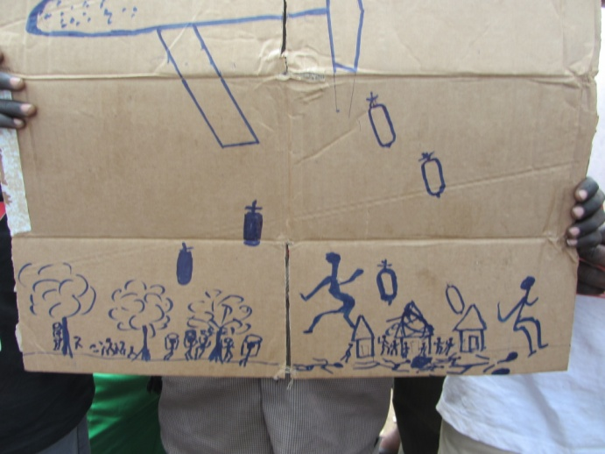
Blue Nile Youth Plea: ’Stop Aerial Bombardment’

The Humanitarian Situation is desperate: people are unable to plant or harvest crops because of aerial bombardment; many people have been forced to hide in the banks of rivers. Some have developed coping mechanisms, such as foraging for food – roots of trees, wild plants – but these become very scarce in the dry season. In what should be the ‘fat season’, people are already reporting empty food stores and death from starvation. ‘We lived in the bush all through the rainy season, with no shelter, wet clothes; we are too frightened to build shelters as they will be bombed. We have no plastic sheeting, no blankets; we are cold and we just sit there in the rain.’
There is acute concern over the implications of the war for children, especially the difficulty of providing education: schools have been destroyed aerial bombardment discourages children from attending school.
‘We have to keep moving all the time. We try to feed our children and they have no school. We didn’t bring our children with us today for fear of the Antonovs.’
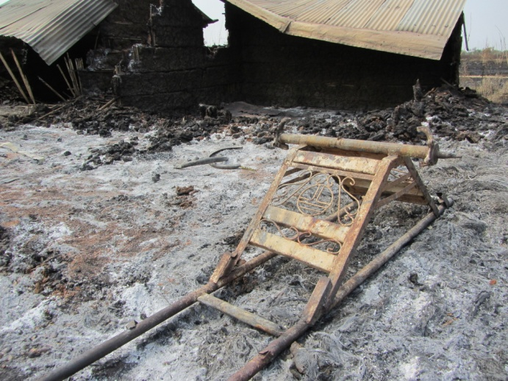
Fire-bombed market, Yabus, Blue Nile
Atrocities perpetrated by Khartoum’s forces: The worst atrocities have been perpetrated in and around Kirmuk. On December 12th 2012, 1700 civilians from Ulu Payam (Kirmuk County) left for South Sudan; they were attacked by SAF Sudan Armed Forces) ground forces, many were killed and many children scattered; only 700 of the original 1700 arrived in Maban, South Sudan

Forced Displacement: 111,000 people have been forced by the aerial bombardment and associated problems of lack of food, education and health care, to flee to four camps in Maban County.

Commitment to Stay in Blue Nile: However, we met many destitute, emaciated people who were determined not to flee: ‘This is our land. We have made a decision that we will never leave. We are fed up with running. We don’t where to go. Now we will never go to another people’s land. President Omer Al-Bashir is there but we do not like him. We will not go to the North or the South. Perhaps we will die here but we will not run.’

Southern Kordofan (Nuba Mountains)

Aerial bombardment is continuing daily, often targeting markets and schools, or random bombing of civilian areas. When ground offensives are operational, the number of bombs dropped may reach 60 per day; including night-time attacks.
Variable types of bombs were widely reported: until November 2011, SAF were only using bombardment by Antonovs and helicopters; subsequently, they have deployed long-range shells (Uishi missiles) and more recently incendiary bombs to burn buildings, grass and crops.
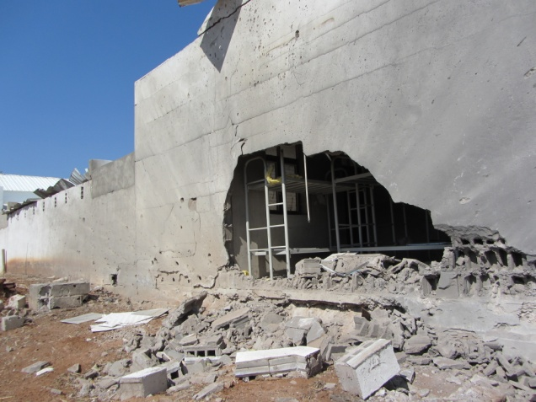
Peace High School for Girls, Kauda, Southern Kordofan

The Humanitarian Crisis: The NCP (National Congress Party in Khartoum) has reneged on agreements to allow access by humanitarian aid organisations to reach civilians in need of food, clean water and health care. As a result of continuing aerial bombardment, around 57,000 have made the arduous journey on foot to South Sudan where their main destination is the camp at Yida. Thousands more have taken refuge in caves where they live in danger of deadly snakes, often far from access to food or clean water. As one woman said:
‘We have been living in the caves since June 2011, despite deadly snakes. We just pray to God to protect us from the snakes.’
The sustained aerial bombardment has also prevented people from planting or harvesting crops, causing serious and escalating malnutrition and associated diseases. Heiban County has been most affected, with an estimated 80% crop failure.
We were shown the kinds of roots and wild fruits which they are now forced to eat, with little nutritional value, often causing gastro-intestinal problems.

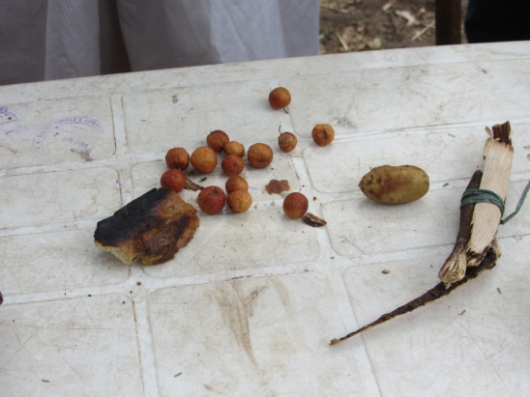
IDPs display their ‘food’
Health care: there is an acute shortage of health care provision and no Immunization Programme (EPI). One health worker was deeply critical of the failure of the international community to provide resources for EPI:
‘UNICEF is not providing vaccines because this is ‘cross-border’ so it is not possible to provide Immunizations although all the equipment for cold chain storage is available. Therefore, there is high incidence of cases which should be prevented such as pertussis and measles. It is madness that UNICEF won’t provide vaccines for children: these can hardly be given to soldiers.’

The Agreements in Addis Ababa on humanitarian access: In July 2012, Khartoum ‘accepted’ the tripartite proposal for Humanitarian access into South Kordofan and Blue Nile – but so far all aid has been prevented. The Tripartite Agreement is seen as having done more harm than good, because without it, people would have made the journey to South Sudan earlier. The Agreement’s false promises gave them hope - they waited for months, living on roots of trees and whatever they could scavenge. When they finally decided to move, many were too exhausted to carry children and to undertake the journey to the South. Local people perceive Western Governments who accepted the Agreement as complicit with the results of Khartoum’s deception.

Recommendations

- The international community must require Khartoum to cease immediately the aerial bombardment of the civilians in Blue Nile and Southern Kordofan so that civilians can return to their homes, live in security, harvest their crops and begin to restore essential services including education and health care. Failure to take necessary measures to stop this sustained aerial bombardment is tantamount to condoning another attempted genocide.

- The UNSC should initiate an Investigation by the International Criminal Court (ICC) into war crimes and/or crimes against humanity perpetrated by the NCP in Southern Kordofan and Blue Nile. If the UN Security Council will not agree a Resolution to this effect, an alternative appropriate body should initiate this request to the ICC.

- Urgent provision of humanitarian aid to IDPs in Nuba Mountains and Blue Nile. Failure to respond to their needs can be seen as complicity with Khartoum’s policy of attempted ethnic cleansing of the civilians from these lands. In the words of one medical doctor:
‘Deliberately to deny life-saving aid is a crime against humanity’.
Baroness Cox, HART CEO, said ‘For 20 years I have visited the Sudanese peoples suffering from Khartoum’s genocidal policies, seeing innocent civilians dying from military offensives, starvation and preventable disease. Khartoum is continuing to kill its own people with impunity. If the international community continues to fail to intervene in ways which will stop this ethnic cleansing of the peoples of Blue Nile and Southern Kordofan it will be seen as complicit .’

