HART coverage in the Church Times – 8th March 2019
Dozens of churches burned in Sudan
More than 30 churches have been burned down in the Nuba Mountains area of Sudan
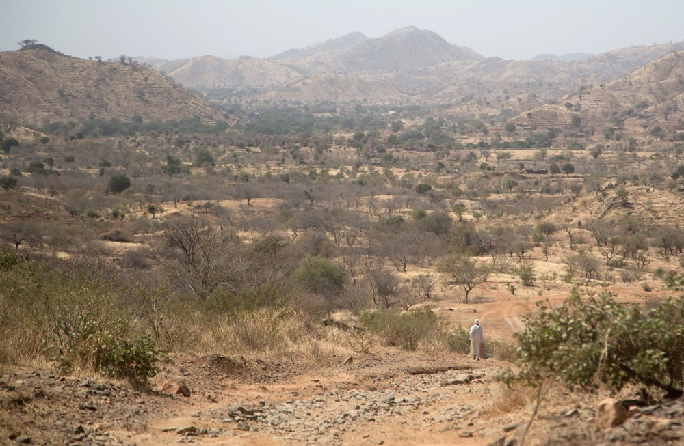

AT LEAST 32 churches have been burned down in the Nuba Mountains area of Sudan over the past year, opposition leaders have said, with reports that up to 40 more may have been demolished.
Baroness Cox visited the region of the Nuba Mountains in Southern Kordofan last month with her charity Humanitarian Aid Relief Trust (HART), before flying to South Sudan to collect testimony from regional leaders and communities. In the Nuba Mountains, her team found that thousands of people were still displaced after years of conflict and are too terrified to return home.
Although a ceasefire is technically in place between the Sudanese government of President Omar al-Bashir, who has been indicted by the International Criminal Court for war crimes, and the Sudan People’s Liberation Movement North (SPLM-N), military planes from the Sudanese airforce still fly overhead, and local officials told the HART team that the conflict continued, with frequent indiscriminate attacks on Christians.
The Commissioner for the Nuba Montains, David Isaiah, told Lady Cox and her team: “The government of Sudan is using every means to mislead the world into thinking there is no war in the Nuba Mountains.”
The Nuba conflict is an extension of the long civil war that eventually provided South Sudan with its independence in July 2011 (News, 1 July 2011). The Nuba people played a key part in helping the former South Sudan rebel forces to gain sovereignty. But, in the mineral-rich areas of the Nuba Mountains and the Blue Nile State, promises of autonomy were unfulfilled, and suspected rigged local elections triggered renewed fighting between the Sudan government and the rebels.
The areas are still home to many Christians, although the population is religiously mixed, including animists and Muslims.
The deputy chair of SPLM-N, General Jagot Mukwar, said: “Antonovs [Sudan’s military aircraft] have not dropped bombs for two years. But we hear that government troops could be moving closer. In November and December, civilians were ambushed on the main road in Habila. It happened three times in two months. Two weeks ago, a farm was burnt, also in Habila. The government is killing its own people. They are burning churches. They do not want people to be Christians. They want us to speak in Arabic. They want us to have Arabic names.”
Lady Cox called for cross-border aid to be allowed into the region to reach communities who were not able to trust aid that came from the Sudanese capital, Khartoum. And she demanded that the UK Government review its policy of continuing trade links with Sudan, despite acknowledging that there had been no improvement in human rights.
President al-Bashir is under growing pressure to step down, after the spread of anti-government protests which began in December over a sharp rise in the price of bread. As a result of the protests, he has imposed a year-long state of emergency, placing even heavier restrictions on the press and opposition leaders, and giving security forces a free hand to crack down on protesters. Nevertheless, thousands of people went on strike on Tuesday in protest, Associated Press reported.
The President has also announced that he would postpone pushing for constitutional amendments that would have allowed him a third term in office.

