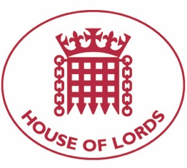
Hansard: Written Question on Syria: Coronavirus
18 June 2020

Baroness Cox: To ask Her Majesty's Government, further to the Written Answer by Lord Ahmad of Wimbledon on 18 June (HL5354) which outlined potential delays to “the provision of goods to Syria's pharmaceutical industry”, what steps they are taking to mitigate (1) any damage to that country’s ability to deal with the COVID-19 pandemic, and (2) any impact of sanctions on Syrian civilians.

Answered 10 July 2020

Lord Ahmad of Wimbledon: The UK is working closely with the UN and our humanitarian partners to respond to the outbreak of COVID-19 in Syria and sustain life-saving services there. On 30 June, the International Development Secretary announced a UK pledge of at least £300 million for the Syria crisis in 2020. The funding will help stop the spread of the virus in Syria by supporting health workers with training, medical supplies and sanitation.
As previously stated in my Written Answer (HL5354), medical equipment and medicines required to fight the COVID-19 pandemic are not subject to direct restrictions on export, supply, financing or use in Syria.

Hansard: Written Question on Syria: Sanctions
18 June 2020

Baroness Cox: To ask Her Majesty's Government whether the same exceptions to sanctions applicable to international humanitarian organisations also apply to healthcare agencies that are part of the government of Syria.

Answered 10 July 2020

Lord Ahmad of Wimbledon: We can confirm that healthcare agencies that are part of the Syrian regime are not designated under EU sanctions.

