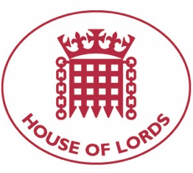
Hansard: Written Question on Nagorno Karabakh: Armed Conflict
12 October 2020

Baroness Cox: To ask Her Majesty's Government what assessment they have made of reports that foreign mercenaries and jihadist fighters have been deployed by Azerbaijan in the Nagorno-Karabakh region; and what discussions they have had with the government of Azerbaijan about the presence and role of these groups in the Nagorno-Karabakh conflict.

Answered 14 October 2020

Baroness Sugg: The UK is aware of media reporting that foreign fighters may be involved in fighting in and around the Nagorno-Karabakh conflict zone. External intervention in the conflict risks prolonging it and is not in anyone's interests. The UK continues to urge all actors to use their influence to ensure an end to the hostilities and a return to the negotiating table.

Hansard: Written Question on Nagorno Karabakh: Politics and Government
12 October 2020

Baroness Cox: To ask Her Majesty's Government what assessment they have made of proposals to give the Nagorno-Karabakh region independence; and what plans they have (1) to support these proposals, and (2) to ask the OSCE Minsk Group to take these proposals forward as a matter of urgency..

Answered 14 October 2020

Baroness Sugg: The UK supports the OSCE Minsk Group Process and the Basic Principles which include a return of the territories surrounding Nagorno-Karabakh to Azerbaijani control and the acceptance of a free expression of will on the status of Nagorno-Karabakh.

