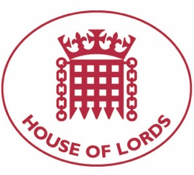
Hansard: Written Question on Syria: Sanctions
2 September 2020

Baroness Cox: To ask Her Majesty's Government, further to the Written Answer by Lord Ahmad of Wimbledon on 16 July (HL6213), (1) when, and (2) how, they intend to transfer existing EU sanctions relating to Syria into UK law; and whether Parliament will be given time to discuss that transfer.

Answered 11 September 2020

Lord Ahmad of Wimbledon: Her Majesty's Government is transferring existing EU sanctions into UK law through regulations made under the Sanctions and Anti-Money Laundering Act 2018, including the Syria (Sanctions) (EU Exit) Regulations 2019. These regulations will come into force on 1 January 2021, at which point existing EU sanctions will become autonomous UK sanctions. The Syria (Sanctions) (EU Exit) Regulations 2019 were debated and approved in both Houses in April and May 2019.

