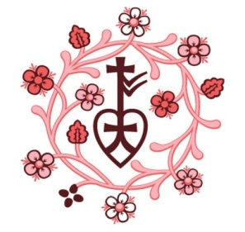
SOUTH SUDAN MARCH-MAY 2019 BRIEFING

JUNE-AUGUST BRIEFING 2018

Highlights

> The SPLM/A-IO accused pro-government militia-men in Wau State of killing 15 civilians and kidnapping six women and three children and called to investigate the criminal assault.
> UN Security Council voted to extend the UN mission in South Sudan by a year.
> Report by UN mission in South Sudan- government armed forces reiterate commitment to not enlist children
> World health Organization (WHO) and their partners assess and respond to the health needs of over 5000 IDPs

Humanitarian Figures

1.91 million Internally Displaced People (IDPs) in South Sudan need humanitarian assistance, according to October reports by (OCHA) 6.1 million people are severely food insecure. South Sudan is facing famine levels of food scarcity (September 2018 Projection, Integrated Food Security Phase Classification) 297,150 people are seeking asylum in South Sudan. Refugee crises in North-East and Eastern Africa continue to pose a humanitarian emergency (OCHA) 2.46 million South Sudanese refugees are being hosted in neighbouring countries. Insecurity in South Sudan continues to drive Africa’s biggest refugee crisis (UNHR Regional Portal, 30 September 2018)

Key Developments

> “Over 140,000 South Sudan refugees who fled the country at the height of the civil war have returned home six months after a peace deal was signed between warring factions of President Salva Kiir and Dr Riek Machar. The returnees, according to South Sudan’s Ministry for Humanitarian Affairs and Disaster Management came from Uganda, Ethiopia, Central African Republic and Sudan.”
> Call for women’s inclusion in South Sudan peace deal implementation. A group of South Sudanese women have launched a petition calling for inclusivity in the upcoming three-year transitional government to implement the outcome of the revitalized peace agreement. "We, South Sudanese women and girls, who are 65% of the population, are the ones who bear wars and violence brunt the most; rape, sexual violence, physical and health vulnerability, and poverty in general," said a group of female activists
> Report from the UN office of coordination of humanitarian affairs: The United Nations Central Emergency Response Fund (CERF) announced an allocation of US$11 million to help 268,000 women, men and children who had been displaced by conflict within South Sudan to return to their homes.

Key Individuals, Places and Groups › Juba: South Sudan’s capital city. Also serves as the capital of Jubek State › Salva Kiir: President of South Sudan (2011- Present) › Riek Machar: Former Vice President (2011-2013) › CTSAMM: The Ceasefire and Transitional Security Arrangements Monitoring Mechanism

Context
South Sudan gained independence from the Republic of Sudan following the Referendum of 2011, which saw 99 per cent of those in the south voting to break away from the north. Political unrest erupted in 2013 after President Salva Kiir accused Vice-President Riek Machar of conspiring against his government. The dispute between government and rebel forces evolved into a devastating civil war that continues to be fought on political allegiances.
A recent report estimates 383,000 people have been killed as a result of civil war in South Sudan: twelve ceasefires have been signed since the humanitarian crisis began in 2013, and none have brought resolution or peace to the nation. Ethnic minorities have been persecuted by inter-communal violence, while other indiscriminate attacks have contributed to the mass-murder, rape and torture of South-Sudanese civilians caught up in the conflict.
South Sudan is the largest contributor to the refugee crisis in East and North-East Africa: insecurity in the region displaces 1.9 million people and forces 2.4 million into other countries as refugees. Brutality, acts of violence and political unrest have given rise to one of the world’s worst situations of food insecurity, displacement and deepening poverty. South Sudan’s reputation as the most dangerous place to be an aid worker makes the challenge of distributing food and medicine those who desperately need it even more difficult.

A Map of the Republic of South Sudan
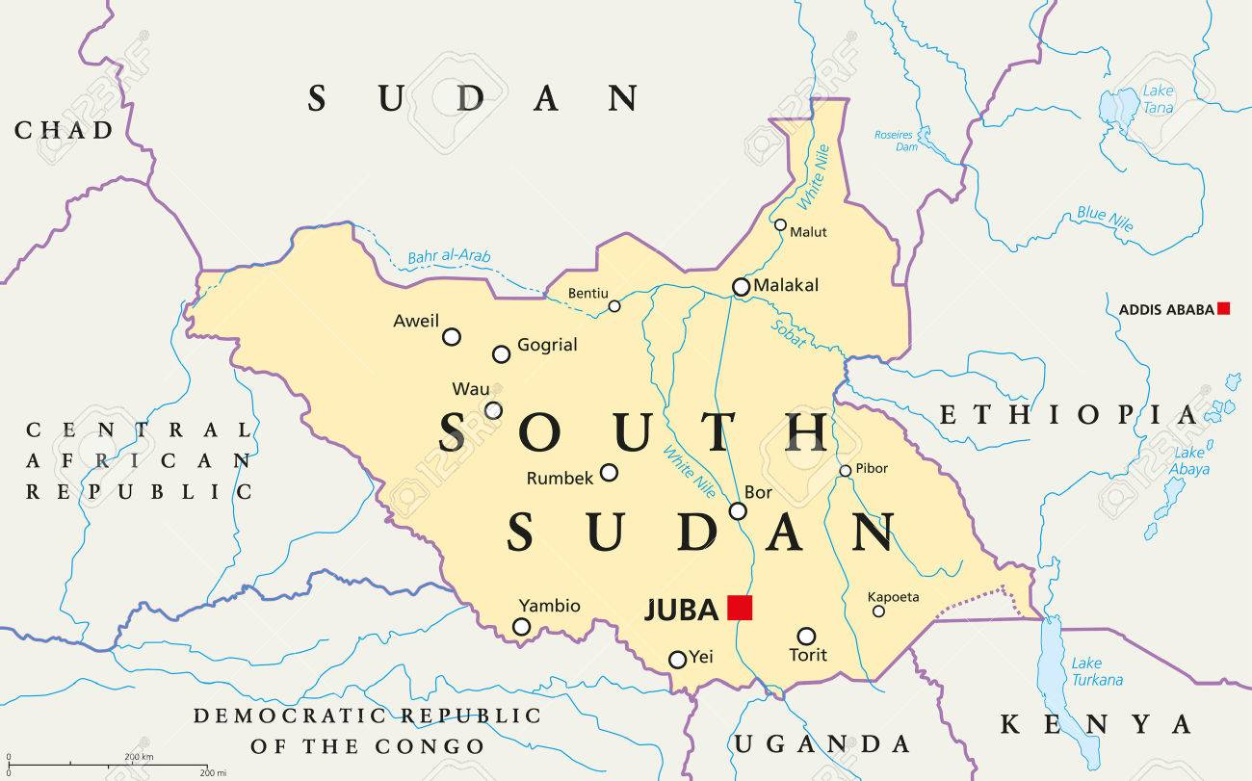
Demographics ……… Based on the latest United Nations estimates, the population now exceeds 13 million. The populace is made up of many ethnic groups, the majority being Dinka who represent 35% of South Sudanese peoples. 80% live in rural areas, and half of the population live below the poverty line. Population estimates in Wau, the region in which HART is active, is estimated at 118, 330.

Latest Developments
Immunization Campaign Underway Following Measles Outbreak
A campaign to immunize nearly 40,000 children against measles was launched in early March following a confirmed outbreak in Mayom, former Unity State. The campaign is being carried out by the Ministry of Health with support from the World Health Organization (WHO), the UN’s Children Fund (UNICEF) and the International Organization for Migration (IOM). The campaign will target children aged from 6 to 59 months in 10 bomas, namely Kuerbona, Mankien, Riak, Ruathnyibol, Kueryiek, Ngop, Pub, Bieh, Wangbour and Wangkei. According to the WHO, “Measles outbreaks in South Sudan are attributed to accumulation of unvaccinated children due to low routine immunization administrative coverage at 59 per cent. Access to health care across the country is extremely limited with less than 50 per cent of the population estimated to live within a five kilometer radius of a health facility. As part of the measles control strategy, countrywide measles campaigns targeting children are implemented every two years.”

Prosecuting Sexual and Gender Based Crimes in South Sudan is Essential for Peace
Report from the UN Human Rights Council- Prosecuting sexual and gender based crimes in South Sudan is essential for peace and ending impunity for conflict-related sexual and gender-based violence is the only way to end its widespread practice in South Sudan. The UN Human Rights Council mandated Commission on Human Rights in South Sudan to discuss approaches to investigating and documenting conflict-related Sexual and Gender-based Violence (SGBV) in South Sudan. The aim of the working session will be to enhance documentation and evidence collection, contributing towards the establishment of an effective prosecutorial system for future justice mechanisms, including criminal accountability for sexual and gender-based crimes at national and international levels.

Calls for Justice over Death of Women who Refused Forced Marriage

Rights group Amnesty international (AI) are calling for justice over the death of a 20-year-old woman killed for refusing to marry a man her family had selected for her. “The inhumane consequence of this forced marriage that resulted in her death only highlights the need for an urgent end to this practice” says, Amnesty International. According to a 2017 UNICEF study, 52% of South Sudanese girls are married by the time they are 18.

Riek Machar Refusing to Return to South Sudan

South Sudan’s rebel leader Riek Machar, who was meant to return to South Sudan in May and join a power-sharing government as vice president with President Salva Kiir after the signing of a peace deal in September last year, wants to postpone the formation of a unity government, refuses to go to juba without proper safety arrangements. He also asked to hold off on this formation of the unity government for at least another six months. The six month extension was granted.

Continuous Threats to Relief Operations in Eastern Equatoria State, While Improving Humanitarian Access in Central Equatoria State

According to a USAID report, “Insecurity and bureaucratic impediments in other areas of the country continue to pose threats to relief operations. On April 17, unknown armed actors robbed humanitarian non-governmental organization (NGO) workers traveling on a road in Eastern Equatoria State. In addition, local authorities demanded fees and permissions from humanitarian actors in two incidents in Upper Nile’s Malakal town in mid-April. [However] humanitarian access in and around Central Equatoria State’s Yei town is improving after months of insecurity and resultant disruptions to transportation and relief operations in the town and surrounding areas. As a result, humanitarian organizations provided emergency assistance to nearly 5,400 individuals in and around the town in mid-April.”
UN Believes South Sudanese Government Responsible in 2017 Deaths of Opposition activists
Following an investigation of apparent 2017 killings of South Sudanese Activists, A new U.N. report says South Sudanese security agents likely executed two prominent critics of the government who vanished in Kenya in January 2017. Intelligence sources told Africa Review on Sunday the bodies of lawyer Dong Samuel and opposition politician Izbon Agrey Idri were dumped in a river. South Sudan and Kenya deny knowledge or involvement in the disappearance of the two critics of President Salva Kiir.
Further Reading
HART Visit Report: South Sudan and the Nuba Mountains in Sudan

