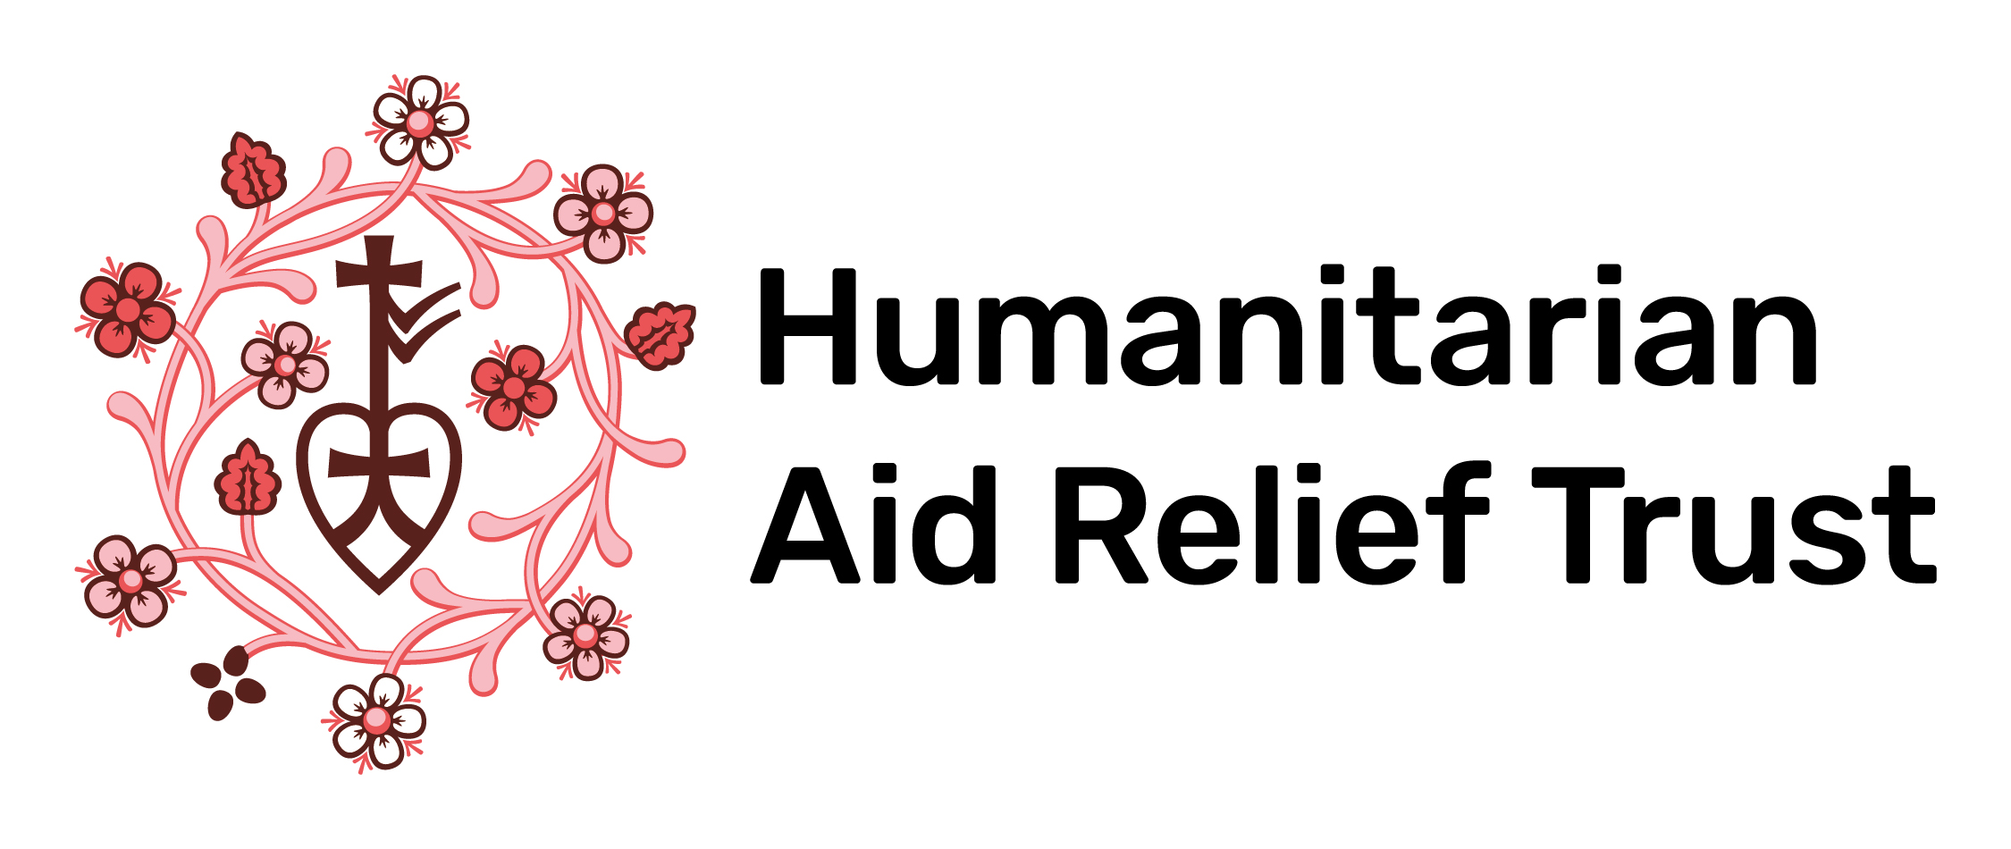

Social Media and Communications Internship Application

Please attach a CV and email this form to bethany.oliver-dee@hart-uk.org

Personal Details

Name:
Email Address:
Telephone number:
City:

Why are you interested in undertaking an internship with HART? What skills would you bring to our team? (Max 200 words)

How would you balance your internship at HART with other commitments, such as other work or studies, to ensure that you are meeting deadlines effectively? (Max 100 words)

Why do you think it is important that young people engage with human rights issues? (Max 200 words)

Do you have any experience with social media campaigning? If so, what lessons have you learned? If not, what do you think makes a successful social media campaign? Please refer to examples you have seen. (Max 200 words)

Please write a short blog post covering recent developments on a human rights issue in one of HART’s areas of operation. (Max 300 words)

